R. S. V. P.

For the 50th Anniversary Celebration for
Fr. Albert Bunsic of the Sacred Heart, O.C.D.
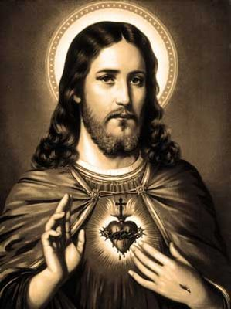
I / We wish to attend the celebration for Fr. Albert on Saturday, June 3, 2017, as follows:

Number in party: ___________________________
Attendance at both the Mass and the reception
Attendance at the Mass only
Attendance at the reception only

Name(s): _________________________________________________________

________________________________________________________________

