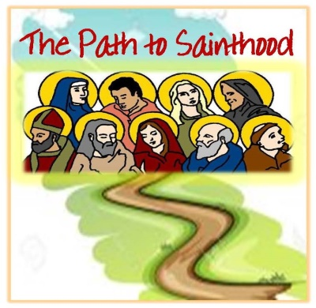
customizable PDF form; you can type your desired information in the text fields and print or save to your computer. (This box will not print.)
St. Therese - St. Lucy - St. Valentine - St. Peter - St. Joseph - Joan of Arc - St. Titus - St. Michael the Archangel - St. Nicholas and many more… Holidays, Martyrs, American, Carmelites and Heroes!

Participant

Registration Form

VBS is July 30-August 3 from 9am – 1pm

TK – 6th grades
Vacation Bible School ~ 30 Saints Who’ve Paved the Way!
{7th grade and above can volunteer as crew or station leaders}

Name: Grade Next Year:

School: $30.00 per participant

Street address:

City:
State:
ZIP:

Parent’s cell phone #: ( )

E-mail address:

* All participants are to bring in their own bag lunch and water each day!
* Please return registration form & payment to the rectory or school office
* Contact: rhondalstorey@gmail.com for any questions or concerns

Allergies or other medical conditions: ________________________________________

In case of emergency, contact: ________________________________________

Phone: ___________________________________________________________

Relationship: ______________________________________________________

*Please see bulletin or flier for more details and information – fliers are in the vestibules and offices!

